VISVESVARAYA TECHNOLOGICAL UNIVERSITY

Jnana Sangama, Belagavi – 590 018


INTERNSHIP REPORT
on
PYTHON WITH DATA SCIENCE

Submitted in partial fulfillment of the requirement for the Award of

BACHELOR OF ENGINEERING

in

Artificial Intelligence and Data Science Submitted By
APPIREDDY GARI CHETAN KUMAR REDDY 1SJ22AD005
Internship carried out at


UNDER THE GUIDANCE OF
INTERNAL GUIDE: EXTERNAL GUIDE:

Mr. Darshan A Irshan M E
Assistant Professor Branch Head

Dept. of AI&DS, SJCIT PySpiders, BTM Layout

DEPARTMENT OF ARTIFICIAL INTELLIGENCE AND DATA SCIENCE

S J C INSTITUTE OF TECHNOLOGY CHICKBALLAPUR – 562 101
2025-26

|| Jai Sri Gurudev||
Sri Adichunchanagiri Shikshana Trust
SJC INSTITUTE OF TECHNOLOGY
Department of Artificial Intelligence and Data Science
CHICKBALLAPUR - 562 101

CERTIFICATE
This is to certify that the Internship Work entitled “PYTHON WITH DATA SCIENCE” is a bonafide work carried out by APPIREDDY GARI CHETAN KUMAR REDDY(1SJ22AD005) in partial fulfillment for the award of Bachelor of Engineering in Artificial Intelligence and Data Science of Visvesvaraya Technological University, Belagavi during the academic year 2025- 26. It is certified that all corrections/ suggestions indicated for the internal assessment have been incorporated in the report. The internship report has been approved as it satisfies the academic requirements with respect to internship work.

.................................  Signature of Guide  Mr. Darshan A  Assistant Professor  Dept. of AI&DS, SJCIT | .........................................  Signature of Coordinator  Ms. Sandhya R  Assistant Professor  Dept. of AI&DS, SJCIT
......................................  Signature of HOD  Dr. Nagaraja G  Professor & HOD,  Dept. of AI&DS, SJCIT | .....................................  Signature of Principal  Dr. G T Raju  Principal, SJCIT,  Chickballapur

EXTERNAL VIVA

Name of the Examiners: Signature of the Examiners:
1.
2.

COMPANY CERTIFICATE

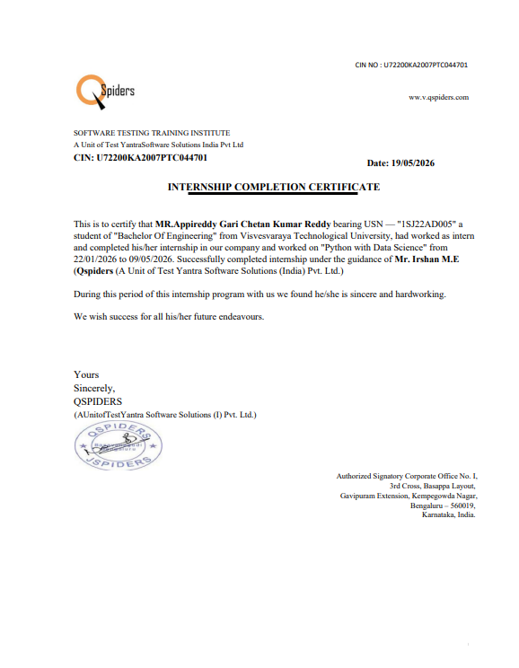

ACKNOWLEDGMENT

With great pride I would like to express my gratitude to S J C Institute of Technology. The temple of learning for providing us the required platform for the fulfillment of the internship.
Remembering with reverence, I offer my pranamas at the lotus feet of Byravaikya Padmabhushana Paramapoojya Jagadguru Sri Sri Sri Dr. Balagangadharanatha Mahaswamiji.
Submitting devout pranamas and seeking the blessings of his holiness Paramapoojya Jagadguru Sri Sri Sri Dr. Nirmalanandanatha Mahaswamiji and poojya Sri Sri Mangalanatha Swamiji.
I express my sincere thanks to Dr. G T Raju, Principal of SJCIT, Chickballapura for providing us with excellent infrastructure to complete the internship.
I express wholehearted gratitude to Dr. Nagaraja G who is the respectable HOD, AI&DS Department. We wish to acknowledge the support for making our task easy by providing us with all valuable help and encouragement.
I sincerely thank my Internship Coordinator, Ms. Sandhya R, Assistant Professor, for her invaluable guidance, encouragement, and insightful suggestions.
It is my privilege to thank my Guide Mr. Darshan A, Assistant Professor, for his guidance, encouragement, support and valuable suggestion for completion of my Internship.
And last but not the least, I would be very pleased to express my heartfelt thanks to PySpiders, BTM Layout for their guidance and support provided to complete the internship.
I also thank all those who extended their support and co-operation while bringing out this internship.
Finally, I would like to thank our family members and friends for their kind co-operation and motivation to proceed in my Internship work.

A CHETAN KUMAR REDDY (1SJ22AD005)

ABSTRACT

Over a period of four months at PySpiders, BTM Layout, Bengaluru, an intensive internship was undertaken spanning the core disciplines of modern data science and artificial intelligence. Technical training covered advanced Python programming, data manipulation and parsing, structured software engineering design patterns, environment configuration management, and vector database mechanics. Foundational machine learning concepts—encompassing text preprocessing, semantic embedding generation, vector space mathematics, and large language model (LLM) orchestration—were studied alongside state-of-the-art frameworks to build secure, production-grade applications.
The capstone project of the internship is the design and development of an AI Code Explainer Tool—an enterprise-grade, memory-safe Retrieval-Augmented Generation (RAG) platform built with Python, Streamlit, LangChain, and the Google Gemini 1.5 Pro API. The application allows users to securely upload repository code documents (such as .py files) and input natural language queries to receive contextually accurate, structural markdown explanations complete with chunk-level code citations. To ensure system reliability and prevent context window exhaustion, a custom pipeline was implemented featuring programmatic input validation, robust UTF-8 exception-safe string decoding, and a recursive semantic chunker that preserves the logical structure of code functions. Vectorized chunks are indexed locally on-disk using a high-performance ChromaDB vector engine to facilitate rapid top-K semantic lookups.
The internship established a solid practical foundation in industry-standard data science tooling, professional software development practices, and applied artificial intelligence—substantially advancing readiness for a career at the intersection of software engineering and intelligent systems.

CONTENTS

ACKNOWLEDGMENT |  | I
ABSTRACT |  | II
LIST OF FIGURES |  | III
LIST OF TABLES |  | IV
Chapter No. | Chapter Name | Page No.
1 | COMPANY PROFILE | 1-4
1 | 1.1 Overview of the Organization | 1
1 | 1.2 Core Services and Offerings | 1-2
1 | 1.3 Technology Domains and Industry Alignment | 2-3
1 | 1.4 Internship Duration and Schedule | 3-4
2 | FIELD: Data Science & Artificial Intelligence | 5-9
2 | 2.1 Overview of the Field | 5
2 | 2.2 Relevance to BE in Artificial Intelligence and Data Science | 5-7
2 | 2.3 Industry Applications of the Field | 7-8
2 | 2.4 Tools and Technologies in the Field | 8-9
3 | INTRODUCTION TO DATA SCIENCE | 10-18
3 | 3.1 About Data Science | 10-11
3 | 3.2 Python as the Language of Data Science | 11-14
3 | 3.3 Introduction to Machine Learning | 14-16
3 | 3.4 Generative AI and RAG | 16-18
4 | IMPLEMENTATION AND RESULTS | 19-29
4 | 4.1 Project Overview and Motivation | 19-20
4 | 4.2 Project Objectives | 20-21
4 | 4.3 System Architecture | 21-22
4 | 4.4 Module-wise Implementation | 22-26
4 | 4.5 Results and Output | 26-29
5 | ADVANTAGES, DISADVANTAGES AND APLLICATIONS | 30-332
6 | REFLECTION | 33
 | CONCLUSION | 34
BIBLOGRAPHY |  | 35
APPENDIX |  | 36-40

Table No. | Title | Page No.
Table 1.1 | Company Details | 1
Table 1.2 | PySpiders Key Service Domains | 2
Table 2.1 | Field-to-Curriculum Alignment Matrix | 6
Table 2.2 | Industry Applications Summary | 7
Table 3.1 | Python Data Types with Examples | 11
Table 3.2 | Core OOP Principles Summary | 12
Table 3.3 | Key Pandas Functions Reference | 13
Table 3.4 | ML Algorithm Comparison | 16
Table 3.5 | RAG vs Pure LLM Comparison | 18
Table 4.1 | Project Technology Stack | 20
Table 4.2: | Complete Data Flow Steps | 25
Table 4.3 | Module Function Reference | 26
Table 4.4 | Validation Test Cases and Results | 28

LIST OF TABLES

LIST OF FIGURES
Figure No. | Title | Page No.
Figure 4.1 | Model Architecture | 21
Figure 4.2 | Flow chat | 22
Figure 4.3 | Use Case | 22
Figure 4.4 | Interface of AI Data Analyst Chatbot | 26
Figure 4..5 | Overview of the uploaded dataset | 27
Figure 4.6 | Explanation for the code logic | 27

CHAPTER1

COMPANY PROFILE

1.1 Overview of the Organization
PySpiders Pvt. Ltd. is a premier technology training and consulting organization headquartered in BTM Layout, Bengaluru — one of India's most vibrant technology hubs. Established with the singular mission of democratizing access to cutting-edge technical education, PySpiders has grown over the years into a recognized institution that bridges the critical gap between academic knowledge and industrial expectations in the field of Software Development, Data Science, and Artificial Intelligence.
The company derives its name from the 'Spider' metaphor — an organism renowned for its precision, patience, and the ability to weave intricate yet strong structures. This metaphor resonates deeply with the organization's approach: developing professionals who can construct robust, maintainable, and intelligent software systems with the same precision and thoughtfulness.
Located at BTM Layout, Bengaluru a locality that has organically evolved into a micro-hub for technology startups, coding bootcamps, and IT service firms PySpiders benefits from a rich ecosystem of talent, industry partnerships, and geographical proximity to major technology employers such as Amazon, Flipkart, Infosys, and numerous AI-focused startups.
Company Name | PySpiders
Location | BTM Layout, Bengaluru, Karnataka
Founded | 2015
Type | Technology Training & Software Development
Primary Domain | Python, Data Science, AI/ML, Full Stack
Clientele | Students, Corporates, Startups
Website | www.pyspiders.com

Table 1.1: Company Details

1.2 Core Services and Offerings
PySpiders offers a comprehensive, carefully curated portfolio of technology training and consulting services, structured to serve learners at varying stages of their professional journey. The organization's offerings span both foundational and advanced technology domains, with a curriculum that is regularly updated to reflect the latest industry trends and employer requirement

Service Domain | Key Technologies Covered | Target Audience
Python Programming | Python 3.x, OOP, File I/O, Decorators, Generators | Beginners to Intermediate
Data Science & Analytics | Pandas, NumPy, Matplotlib, Seaborn, Power BI | UG/PG Students, Analysts
Machine Learning & AI | Scikit-learn, TensorFlow, Keras, XGBoost | Intermediate Developers
Generative AI & LLMs | OpenAI API, RAG, LangChain, Prompt Engineering | Advanced Learners
Full Stack Web Development | Django, Flask, FastAPI, React.js, REST APIs | CS/IT Graduates
Cloud Computing | AWS, Azure, GCP, Docker, Kubernetes | Working Professionals
Business Intelligence | Power BI, Excel Dashboards, DAX, Data Modeling | Business Analysts
Internship Programs | End-to-end project development with mentorship | Engineering Students
Table 1.2: PySpiders Key Service Domains
The internship program at PySpiders is among its most impactful offerings. Structured as a four-to-six month engagement, the internship immerses participants in a professional development environment that progresses systematically from foundational technical learning through advanced topics and culminates in the independent development of a production-quality software project. This capstone-driven approach ensures that interns leave with a tangible, demonstrable artifact of their learning — a project they can present to future employers as evidence of real-world development capability.

1.3 Technology Domains and Industry Alignment
PySpiders maintains exceptionally close alignment between its curriculum and current industry demands. The organization's training directors and lead instructors actively monitor technology hiring trends, job description analyses, and industry reports to ensure that the skills being taught are precisely those that employers are actively seeking. This commitment to industry alignment is a key differentiator that contributes to the organization's strong placement track record.
In the 2024–25 period, the curriculum has been significantly expanded to incorporate Generative AI, Large Language Models (LLMs), Retrieval-Augmented Generation (RAG) systems, and vector database technologies — capabilities that have rapidly become among the most sought-after skills in the technology job market. This forward-looking curriculum directly informed the selection and scope of the capstone project undertaken during this internship: the development of an AI Data Analyst Chatbot built on a custom RAG architecture.
The organization's technology domains are deliberately designed to be mutually reinforcing. A student who completes the Python and Data Science track possesses the foundational skills to progress into Machine Learning, which in turn provides the conceptual foundation for understanding Generative AI and LLM application development. This structured progression ensures that learners develop genuine depth of understanding rather than a superficial familiarity with disparate tools.
PySpiders also conducts regular mock interviews, technical assessment sessions, live project evaluations, and industry interaction events that prepare students for the realities of technical hiring processes. Guest lectures by engineering professionals from leading technology companies provide students with direct exposure to current industry practices, emerging technologies, and career development strategies.

1.4 Internship Duration and Schedule
The internship at PySpiders was conducted over a total period of four months, following a structured progression designed to build technical competence systematically before transitioning to independent project development.
The first two months of the internship were dedicated to structured technical learning modules, covering the complete data science and AI development stack in a carefully sequenced curriculum. Each module combined conceptual instruction with hands-on laboratory exercises, mini-projects, and assessments designed to reinforce learning and identify areas requiring additional attention. Modules covered during this phase included: Python programming (fundamentals through advanced topics), Pandas and NumPy for data manipulation and numerical computing, Matplotlib and Seaborn for data visualization, Microsoft Excel for spreadsheet analytics, Power BI for business intelligence reporting, and foundational machine learning with Scikit-learn.
The final two months of the internship shifted focus to independent project development. Working under the mentorship of the external guide, Mr. Irshan M E, the capstone project — the AI Data Analyst Chatbot — was conceived, architected, implemented, tested, and documented. This project development phase provided experience in the complete software development lifecycle: requirements analysis, system architecture design, iterative implementation, debugging, testing with pytest, and comprehensive documentation.
The daily schedule during the internship typically comprised six to seven hours of structured activity, divided between morning technical sessions (for learning module content during the first phase, or focused project development during the second phase) and afternoon practical work (laboratory exercises, code reviews, and mentoring interactions). Weekly progress reviews with the external guide ensured continuous alignment with project objectives and provided regular opportunities for technical guidance and course correction.

CHAPTER 2
FIELD: DATA SCIENCE & ARTIFICIAL INTELLIGENCE

2.1 Overview of the Field
Data Science and Artificial Intelligence collectively represent one of the most consequential and rapidly evolving fields in the history of technology. Data Science is an interdisciplinary discipline that combines principles and practices from mathematics, statistics, computer science, and domain expertise to extract meaningful knowledge and actionable insights from structured and unstructured data. Artificial Intelligence is the broader project of enabling machines to exhibit behaviours associated with human intelligence — reasoning, learning, problem-solving, perception, and language understanding.
The two fields are deeply intertwined: modern AI systems are fundamentally data-driven, relying on large datasets and statistical learning algorithms to acquire their capabilities. Data Science provides the methodological toolkit — data collection, preprocessing, analysis, and modeling — that makes AI development possible, while AI provides Data Science with increasingly powerful computational tools for pattern recognition, prediction, and automation at scales that were previously unachievable.
The term 'Data Science' gained mainstream recognition in the early 2000s, though its intellectual roots extend back decades to foundational work in statistics, information theory, and computational mathematics. The exponential growth of digital data generated by internet-connected devices, social media platforms, e-commerce systems, and sensor networks created both the necessity and the opportunity for a discipline capable of making sense of data at unprecedented scale and complexity.
Today, Data Science and AI are not merely academic disciplines — they are core business functions. Organisations that effectively leverage these capabilities consistently demonstrate superior performance in customer acquisition, operational efficiency, product innovation, and risk management. The global AI market is projected to exceed USD 1.8 trillion by 2030, reflecting the growing recognition of data and intelligence as among the most valuable assets an organisation can possess. For engineering graduates in 2025, proficiency in this field represents one of the highest-value career investments available.

2.2 Relevance to BE in Artificial Intelligence and Data Science
The Bachelor of Engineering program in Artificial Intelligence and Data Science (AI & DS) at S J C Institute of Technology is specifically designed to prepare students for careers at
the forefront of intelligent systems development and data-driven decision making. The curriculum is structured to provide both the theoretical foundations of AI and data science and the practical engineering skills required to build and deploy real-world intelligent systems.
Academic Subject | Internship Module | Direct Connection
Mathematics for ML (Linear Algebra, Probability) | NumPy, Scikit-learn | Matrix ops, probability distributions
Programming in Python | Python (All Modules) | Direct application of curriculum language
Data Structures & Algorithms | Chunker, Retriever (RAG) | Efficient data structures for retrieval
Database Management Systems | Pandas, CSV Processing | Data querying and manipulation
Machine Learning | Scikit-learn (Cosine Similarity) | Algorithm implementation
Natural Language Processing | LLMs, Tokenization, Embeddings | Core project technology
Software Engineering | Modular Architecture, pytest | System design and testing
Data Visualization | Matplotlib, Seaborn, Power BI | Visual analytics and reporting
Table 2.1: Field-to-Curriculum Alignment Matrix
The alignment between the internship domain and the AI & DS curriculum is exceptionally precise. Every technical module covered during the four months of the internship corresponds directly to one or more subjects in the academic program. The internship therefore served not merely as an industrial exposure exercise but as a deep, applied extension of the curriculum — demonstrating that the theories taught in the classroom have concrete, practical manifestations in real software systems.
The capstone project — the AI Data Analyst Chatbot — is particularly significant in the context of the AI & DS program. It integrates natural language processing, vector embeddings, semantic search, large language model orchestration, and full-stack web application development into a single, coherent production system. Building this system required and demonstrated competency across virtually the entire breadth of the AI & DS curriculum, providing tangible evidence that academic learning translates meaningfully into real engineering capability.

2.3 Industry Applications of the Field
The Data Science and AI field finds application across virtually every major industry vertical, making it one of the most versatile and transferable technical skill sets in the modern economy. The following survey illustrates the breadth and depth of real-world applications:
Industry | Key Applications | AI/DS Technologies Used
Finance & Banking | Fraud detection, algorithmic trading, credit scoring | ML models, anomaly detection, time series
Healthcare | Medical imaging, drug discovery, patient outcome prediction | CNN, NLP, survival analysis
E-Commerce & Retail | Recommendation engines, demand forecasting, sentiment analysis | Collaborative filtering, LSTM, NLP
Manufacturing | Predictive maintenance, quality control, supply chain optimization | IoT analytics, computer vision
Government & Public Sector | Census analysis, traffic optimization, public health surveillance | Geospatial analytics, epidemiological models
Education | Adaptive learning, student performance prediction, content recommendation | NLP, recommendation systems
Legal & Compliance | Contract analysis, regulatory document review, case outcome prediction | RAG, NLP, LLMs
Media & Entertainment | Content recommendation, audience analytics, deepfake detection | Collaborative filtering, GANs
Table 2.2: Industry Applications Summary
Of particular relevance to this internship is the rapidly expanding category of AI-powered document intelligence applications — systems that enable organisations to extract insights from their proprietary document collections through natural language interfaces. This category, exemplified by the AI Data Analyst Chatbot project, is experiencing explosive growth as organisations seek to democratize access to the knowledge embedded in their internal documents, reports, contracts, and data files. The RAG architectural pattern that underpins the project has become the dominant approach for this class of application, making the skills developed during the internship immediately applicable across a wide range of industry contexts.

2.4 Tools and Technologies in the Field
The Data Science and AI field is defined not merely by theoretical principles but by a rich, interconnected ecosystem of tools, libraries, platforms, and services that practitioners use to accomplish their work. The internship provided systematic, hands-on experience with the core tools of this ecosystem:
- Python 3.10+ — The universal language of data science and AI — an interpreted, dynamically typed, general-purpose language whose clean syntax, rich standard library, and unmatched ecosystem of purpose-built packages make it the indispensable foundation of the entire field.
- Pandas — The primary library for data manipulation and analysis — providing DataFrame and Series structures that enable intuitive, expressive operations on tabular data, from cleaning and transformation through aggregation and feature engineering.
- NumPy — The high-performance numerical computing foundation — offering N-dimensional array operations, linear algebra routines, and statistical functions that underpin machine learning algorithm implementations throughout the ecosystem.
- Matplotlib & Seaborn — The core visualization stack — enabling creation of publication-quality statistical graphics for both exploratory data analysis and stakeholder communication.
- Scikit-learn — The industry-standard machine learning library — providing consistent, well-documented implementations of classical ML algorithms, preprocessing utilities, model selection tools, and evaluation metrics.
- Microsoft Excel & Power BI — The business analytics dimension of the field — tools that bridge technical data science and business decision-making through interactive, accessible reporting and dashboard creation.
- Streamlit — The preferred framework for rapid Python-native web application development — enabling deployment of interactive AI tools without requiring front-end web development expertise.
- OpenAI API — Access to state-of-the-art large language models and embedding models — powering the generative and semantic search capabilities of modern AI applications including the capstone project.
- Tiktoken — OpenAI's own tokenizer — enabling precise, token-aware text chunking that prevents context window violations in LLM-based applications.
- Pytest — The industry-standard Python testing framework — ensuring code correctness through automated unit and integration tests.

CHAPTER 3

INTRODUCTION TO DATA SCIENCE

3.1 ABOUT DATA SCIENCE
Data Science is an interdisciplinary field that combines mathematics, statistics, computer science, and domain knowledge to extract actionable insights from data. It represents one of the most transformative intellectual developments of the twenty-first century — fundamentally changing how organisations understand their operations, anticipate future events, and make decisions in the face of uncertainty.
At its core, Data Science addresses a question that is deceptively simple but extraordinarily challenging to answer well: given a collection of data, what can we learn from it, and how can that learning be used to make better decisions? Answering this question in practice requires a sophisticated pipeline of interconnected activities — data collection and storage, data cleaning and preprocessing, exploratory analysis and visualization, statistical modelling and machine learning, result interpretation, and communication of insights to decision-makers who may have no technical background.
The modern data scientist is therefore a genuinely multi-disciplinary practitioner: part software engineer, part statistician, part domain expert, and part communicator. This breadth of required competence is both what makes data science intellectually challenging and what makes it enormously valuable — a skilled data scientist can contribute meaningfully at every stage of the process through which raw data becomes organisational knowledge.
The evolution of Data Science as a formal discipline tracks closely with the history of computing infrastructure. The exponential growth of digital data — driven by the proliferation of the internet, mobile devices, social media, e-commerce, and sensor networks — created both the motivation and the raw material for a new discipline. The simultaneous decline in the cost of storage and computation made it economically feasible to collect, retain, and process data at scales that were previously impractical. The development of open-source software ecosystems, particularly the Python data science stack, democratised access to sophisticated analytical tools that were previously available only to well-resourced research institutions.
Data Science today encompasses a spectrum of sophistication — from basic descriptive analytics (what happened?) through diagnostic analytics (why did it happen?), predictive analytics (what will happen?), and prescriptive analytics (what should we do about it?). The AI Data Analyst Chatbot developed during this internship operates at the intersection of descriptive
and diagnostic analytics, enabling users to ask natural language questions about their documents and receive contextually grounded, cited answers — representing the frontier of applied data science capability in 2024–25.

3.2 PYTHON AS THE LANGUAGE OF DATA SCIENCE
Python was created by Guido van Rossum and first released in 1991, with design principles emphasising code readability, simplicity, and expressiveness. Over three decades, Python has grown from a scripting language to the dominant programming language of data science, machine learning, and artificial intelligence — a position it consolidated through the development of a rich ecosystem of purpose-built libraries and frameworks that collectively constitute one of the most powerful computational toolkits ever assembled.
CORE PYTHON FUNDAMENTALS
Python's fundamental data types provide a versatile foundation for all data science work:
Data Type | Example | Primary Use in Data Science
int | age = 21 | Indexing, counting, integer arithmetic
float | score = 9.75 | Scientific computation, model metrics
str | name = "Charan" | Text data, NLP preprocessing
bool | is_valid = True | Control flow, filter conditions
list | features = [0.5, 1.2, 0.8] | Ordered collections, feature vectors
tuple | coords = (12.9, 77.6) | Immutable records, dictionary keys
dict | record = {"name":"Charan"} | JSON data, feature mapping
set | tags = {"AI","ML","RAG"} | Unique collections, vocabulary sets
Table 3.1: Python Data Types with Examples
Python's control flow constructs — if/elif/else conditional statements, for loops over iterables, while loops for indefinite iteration, and list/dict/set comprehensions for concise collection construction — provide the expressive power needed for data transformation pipelines. Functions defined with def support positional arguments, keyword arguments, default values, *args, and **kwargs, making them highly flexible and composable building blocks.
OBJECT-ORIENTED PROGRAMMING IN PYTHON
Object-Oriented Programming (OOP) is a programming paradigm that organises software around data objects and the behaviours associated with them. Python's OOP implementation supports all four fundamental principles of object orientation, each of which has direct relevance to data science system design:
OOP Principle | Python Implementation | Data Science Relevance
Encapsulation | Private attributes (__prefix), getter/setter methods | Data pipeline classes hide internal state
Inheritance | class ChildModel(BaseModel): ... | Extending base estimators in Scikit-learn
Polymorphism | Method overriding — fit(), predict() | Consistent API across different ML algorithms
Abstraction | ABC module, abstract base classes | Interface contracts for document loaders, embedders
Table 3.2: Core OOP Principles Summary
The AI Data Analyst Chatbot extensively applies OOP principles: the document loader module uses polymorphic dispatch (different reader functions for each file type behind a common load_document interface), the embedder uses encapsulation (hiding API client management behind a clean get_embeddings interface), and the validator encapsulates validation logic that can be reused across both file and query validation contexts.
KEY DATA SCIENCE LIBRARIES
Pandas are the primary library for data manipulation and analysis, providing the DataFrame — a two-dimensional, size-mutable, heterogeneous tabular data structure — as the central data object. Pandas enables expressive, readable data transformation pipelines through method chaining and a rich function library:

Function | Purpose | Common Usage
read_csv() | Load CSV into DataFrame | Data ingestion from files
head() / tail() | Preview first/last N rows | Quick data inspection
info() / describe() | Structure and statistical summary | EDA and data profiling
loc[] / iloc[] | Label / integer-based selection | Row and column subsetting
fillna() / dropna() | Handle missing values | Data cleaning
groupby() / agg() | Group and aggregate | Summary statistics by category
merge() / concat() | Combine DataFrames | Multi-source data integration
apply() / map() | Element-wise transformation | Feature engineering
pivot_table() | Cross-tabulation | Business reporting
drop_duplicates() | Remove duplicate rows | Data quality improvement
Table 3.3: Key Pandas Functions Reference
NumPy provides the high-performance numerical foundation. Its ndarray — a fixed-size, homogeneous N-dimensional array — enables vectorised operations that are 10–100x faster than equivalent Python loops. Broadcasting allows arithmetic between arrays of different shapes; the linalg module provides matrix inversion, eigenvalue decomposition, and singular value decomposition; and the random module generates samples from dozens of probability distributions. In the RAG pipeline, NumPy underpins the cosine similarity computation that determines which document chunks are most relevant to a user's query.
Matplotlib and Seaborn form the Python visualization stack. Matplotlib's pyplot module provides a MATLAB-like interface for line charts, bar charts, histograms, scatter plots, and pie charts, while its object-oriented API enables precise control over every visual element. Seaborn builds on Matplotlib to provide statistically-oriented visualizations — heatmaps for correlation matrices, pairplots for multivariate EDA, boxplots and violinplots for distribution comparison, and countplots for categorical frequency analysis — with aesthetically refined defaults that make exploratory visualizations immediately presentable.
ADVANCED PYTHON CONCEPTS
- File Handling: Python's open() function with context manager (with statement) provides safe, reliable file I/O across text and binary formats. The csv, json, and pickle modules handle common data serialisation needs; PyPDF2 and python-docx extend this to PDF and Word document formats — both used in the capstone project.
- Exception Handling: The try/except/else/finally construct enables robust error handling. In the AI Data Analyst Chatbot, exception handling is used extensively to manage API errors, file parsing failures, and invalid input conditions gracefully — providing informative user feedback rather than cryptic tracebacks.
- Generators and Iterators: Generators (using yield) produce values lazily, enabling memory-efficient processing of large datasets that would be impractical to load entirely into RAM. This pattern is particularly valuable in the chunking stage of the RAG pipeline, where large documents are processed incrementally.
- Decorators: Higher-order functions that enhance other functions with additional behaviour (logging, caching, authentication) without modifying their core logic. Widely used in web frameworks and the OpenAI Python SDK.
- Memory Management: Python's automatic memory management uses reference counting and a cyclic garbage collector. Understanding these mechanisms is important for writing performance-sensitive data processing pipelines that avoid memory leaks in long-running applications.

3.3 INTRODUCTION TO MACHINE LEARNING
Machine Learning (ML) is the subfield of Artificial Intelligence concerned with developing algorithms and statistical models that enable computer systems to learn from experience — improving their performance on tasks through exposure to data without being explicitly programmed for each scenario. Arthur Samuel, who coined the term in 1959, defined it as 'the field of study that gives computers the ability to learn without being explicitly programmed.'
The fundamental insight underlying machine learning is that many real-world tasks are too complex, too nuanced, or too variable to solve by manually specifying rules. Recognising handwritten digits, translating between languages, predicting which patients are at risk for a disease, detecting fraudulent transactions in real time — these are tasks where the underlying rules are either impossible to articulate explicitly or would require millions of hand-crafted if-then conditions to approximate. Machine learning offers an alternative: given sufficient data and a well-designed learning algorithm, a model can automatically discover the patterns and regularities that define the task.
TYPES OF MACHINE LEARNING
- Supervised Learning is the most widely deployed paradigm. The model is trained on a labeled dataset — input-output pairs where each input is associated with the correct output. The algorithm learns to map inputs to outputs by minimising the difference between predictions and true labels. Applications include email spam classification, house price prediction, medical diagnosis, and credit risk assessment.
- Unsupervised Learning trains algorithms on unlabeled data, requiring the model to discover hidden structure autonomously. Applications include customer segmentation (K-Means clustering), anomaly detection (isolation forests), and dimensionality reduction for visualization (PCA, t-SNE).
- Semi-Supervised Learning combines a small labeled dataset with a large unlabeled dataset valuable when labeling is expensive or time-consuming, such as medical image annotation.
- Reinforcement Learning trains an agent to make sequential decisions through environmental interaction, receiving rewards for beneficial actions. Applications include game playing (AlphaGo), robotic control, and autonomous vehicles.
CORE ALGORITHMS
Algorithm | Type | Key Application | Primary Metric
Linear Regression | Supervised (Regression) | House price prediction | RMSE, R²
Logistic Regression | Supervised (Classification) | Spam detection, medical diagnosis | Accuracy, AUC-ROC
Decision Tree | Supervised | Loan approval, customer churn | Accuracy, F1-score
Random Forest | Supervised (Ensemble) | Fraud detection, feature importance | Accuracy, OOB score
K-Nearest Neighbors | Supervised | Recommendation systems | Accuracy, precision
Support Vector Machine | Supervised | Image classification, text categorization | Accuracy, kernel choice
K-Means Clustering | Unsupervised | Customer segmentation | Inertia, Silhouette score
Table 3.4: ML Algorithm Comparison
MACHINE LEARNING WORKFLOW
- Data Collection — Gathering representative, sufficient data from appropriate sources — the quality and quantity of training data is the primary determinant of model performance.
- Exploratory Data Analysis — Statistical summaries and visualizations revealing distributions, correlations, outliers, and patterns that inform subsequent decisions.
- Data Preprocessing — Handling missing values, encoding categoricals, scaling numerics, and splitting into train/validation/test sets.
- Feature Engineering — Creating informative features from raw data — often more impactful on model performance than algorithm selection.
- Model Training — Fitting the selected algorithm to training data by optimising parameters to minimise a loss function.
- Hyperparameter Tuning — Optimising model configuration using GridSearchCV or RandomizedSearchCV.
- Model Evaluation — Assessing performance on held-out test data using task-appropriate metrics.
- Deployment — Integrating the trained model into a production application via serialisation (joblib/pickle) and API wrapping.

3.4 GENERATIVE AI AND RAG
Large Language Models (LLMs) are a class of deep learning models trained on massive corpora of text data — encompassing books, websites, scientific papers, code repositories, and other textual sources — to learn statistical patterns of language at an extraordinary level of sophistication. The defining characteristic of LLMs is their scale: models like GPT-4 contain hundreds of billions of parameters and are trained on trillions of tokens of text, requiring computational resources that were practically unavailable just a decade ago.
LLMs are trained using a self-supervised objective: given a sequence of text, predict the next token. This seemingly simple task, applied at massive scale, produces models with emergent capabilities far beyond simple next-word prediction — including reasoning, summarisation, translation, code generation, question answering, and creative writing. These emergent capabilities were not explicitly programmed but arose naturally from the training process, representing one of the most surprising and consequential discoveries in AI history.
The OpenAI GPT series (GPT-3, GPT-3.5, GPT-4, GPT-4o) represents the most commercially deployed family of LLMs. The GPT API used in the AI Data Analyst Chatbot project provides programmatic access to these models, enabling developers to integrate state-of-the-art language understanding and generation capabilities without the computational resources required to train or host such models independently.
Generative AI — the broader category of AI systems capable of generating new content (text, images, audio, video, code) that is coherent, contextually appropriate, and often indistinguishable from human-created content — has emerged as the defining technology trend of the mid-2020s, touching virtually every knowledge work domain from software development and legal research to medical diagnosis and creative industries.
However, despite their impressive capabilities, LLMs carry two fundamental limitations. First, the knowledge cutoff problem — LLMs have no awareness of documents or events post-dating their training. Second, hallucination — LLMs sometimes generate confident but factually incorrect responses rather than acknowledging uncertainty. Both limitations are critical concerns in high-stakes professional applications.
Retrieval-Augmented Generation (RAG), formally introduced by Lewis et al. in their 2020 paper 'Retrieval-Augmented Generation for Knowledge-Intensive NLP Tasks,' addresses both limitations by grounding LLM responses in a user-provided external knowledge base. Rather than relying solely on parametric memory (knowledge encoded in model weights), a RAG system first retrieves relevant information from an external document store and provides it as context to the LLM, instructing it to base responses strictly on retrieved content.
A RAG pipeline operates in two phases. During the Indexing Phase, documents are loaded, split into manageable chunks, converted into vector embeddings, and stored in a searchable index.
During the Retrieval and Generation Phase, the user's query is embedded, similarity is computed between the query vector and all chunk vectors, and the most semantically relevant chunks are assembled as context for the LLM.
Central to this process are vector embeddings — dense numerical representations of text that capture semantic meaning in a high-dimensional space. Semantically similar texts produce geometrically proximate vectors, enabling retrieval that transcends keyword matching. A query about 'cardiovascular disease risk factors' retrieves chunks discussing 'heart attack prevention' and 'cholesterol management' — without exact word overlap — because semantic relationships are encoded in the embedding geometry.
Dimension | Pure LLM Approach | RAG Approach
Knowledge Scope | Limited to training data cutoff | Any user-uploaded document, always current
Factual Accuracy | Prone to hallucination | Grounded in retrieved sources
Citability | Cannot cite sources | Explicit [Source N] citations
Privacy | Data sent to LLM provider | Documents processed locally
Cost | High (long prompts) | Efficient (only relevant chunks)
Customisation | Requires fine-tuning (expensive) | Instant via document upload
Table 3.5: RAG vs Pure LLM Comparison

CHAPTER 4

IMPLEMENTATION AND RESULTS
4.1 PROJECT OVERVIEW AND MOTIVATION
The AI Code Explainer Tool is the capstone deliverable of the internship at PySpiders, developed during the final two months of the engagement. The project was motivated by a pervasive challenge in software engineering and technical onboarding: the difficulty developers, code reviewers, and non-technical stakeholders face when attempting to rapidly parse, comprehend, and debug complex or undocumented codebases. Traditional approaches require hours of manual code tracing, reference checking, and structural debugging—creating significant cognitive bottlenecks that limit development velocity and slow down developer onboarding. The tool addresses this challenge directly by providing an enterprise-grade, memory-safe Retrieval-Augmented Generation (RAG) platform that offers a natural language interface to source code files. Users securely upload repository source documents—such as .py files—and ask structural or logic-based questions in plain English, receiving highly accurate, contextually aware markdown explanations complete with actual code chunk citations. This democratization of code comprehension aligns precisely with the broader industry trend toward AI-assisted software engineering work that has accelerated dramatically since the deployment of massive context-window LLM models.
Rather than relying on closed-source or financially prohibitive models, the project implements a robust, state-of-the-art open-ecosystem pipeline leveraging LangChain orchestrations, local persistent vector infrastructure, and Google’s Gemini 1.5 Pro architecture. This architectural decision was deliberate: by building explicit, modular processing components—such as automated file size validators, unified UTF-8 stream decoders, recursive semantic code splitters, and isolated embedding modules—the implementation prioritizes extreme memory safety, deterministic error handling, and logical code preservation. Utilizing an explicit file validator prevents binary file memory faults or server-side RAM exhaustion, while the recursive semantic chunker splits scripts by token boundaries to prevent function logic fragmentation. By managing vector data through an on-disk, SQLite-based local instance of ChromaDB, the system enforces secure data isolation, completely eliminating the network latency and security overhead associated with cloud-hosted vector engines. Ultimately, this production-ready design establishes a highly granular, deeply controlled foundation that easily mitigates typical LLM engineering vulnerabilities such as API rate limits and structural hallucinations.

Technology | Version | Role in Project | Justification
Python | 3.10+ | Core language | Dominant AI/ML ecosystem language
Streamlit | 1.x | Frontend web interface | Fastest Python-native UI for data apps
OpenAI API | GPT-4o | LLM + Embeddings | State-of-the-art accuracy
Pandas | 2.x | CSV parsing and processing | De-facto tabular data standard
Scikit-learn | 1.x | Cosine similarity computation | Battle-tested, optimised implementation
NumPy | 1.x | Array math operations | Foundation for ML numerical computing
PyPDF2 | 3.x | PDF text extraction | Pure Python, no system dependencies
python-docx | 0.8.x | DOCX paragraph extraction | Clean XML-based document reading
Tiktoken | 0.x | Token-aware text chunking | OpenAI's own tokenizer — exact counts
python-dotenv | 1.x | Environment variable management | Secure API key handling
Pytest | 7.x | Automated testing | Industry standard Python test framework
Table 4.1: Project Technology Stack

4.2 PROJECT OBJECTIVES
- Build a Production-Ready Code RAG Platform: Design and deploy a lightweight, memory-safe Retrieval-Augmented Generation system using Python, LangChain, and the Google Gemini 1.5 Pro API.
- Preserve Code Logic and Structure: Implement an optimized, recursive semantic chunking pipeline to break down source files by token bounds without fragmenting logical structures or code functions.
- Establish Local Vector Storage: Configure a high-performance, on-disk ChromaDB instance to manage mathematical vector matrices and execute rapid semantic lookups securely without cloud infrastructure overhead.
- Eliminate AI Hallucinations via Citations: Ensure response reliability by mapping retrieved code segments directly to the UI, providing explicit chunk-level source citations for every explanation generated.
- Deliver an Intuitive Streamlit Interface: Engineer a clean, user-friendly web interface that allows technical and non-technical stakeholders to upload code scripts and query codebase logic in plain English.
- Implement Fail-Safe Exception Handling: Deploy rigid programmatic validation layers to gracefully intercept and resolve memory faults, bad file encodings, missing environment variables, and API rate limits.

4.3 SYSTEM ARCHITECTURE
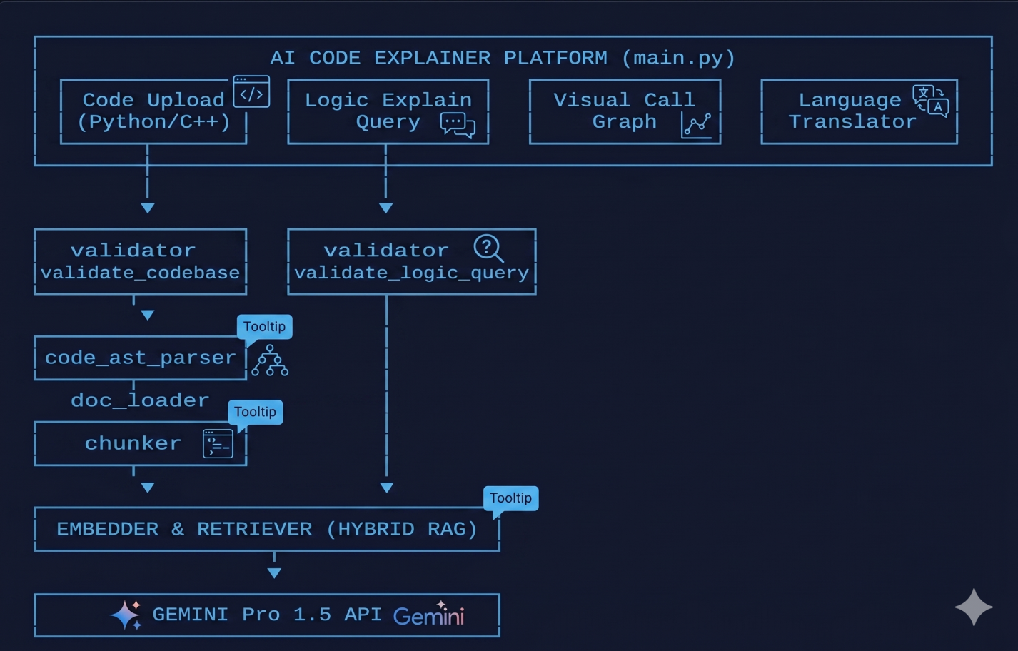
Fig 4.1 Model Architecture
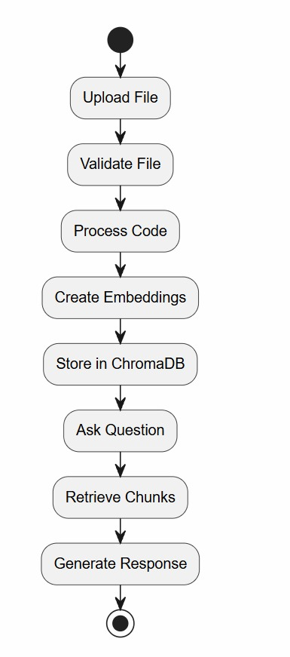
Fig 4.2 Flow chat
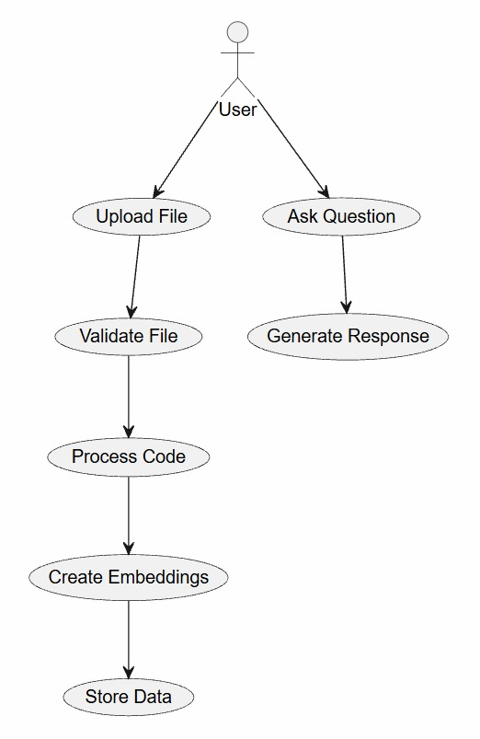
Fig 4.3 Use Case

4.4 MODULE-WISE IMPLEMENTATION
CONFIGURATION MANAGEMENT (CONFIG.PY)
The configuration module provides centralised management of application constants and API key validation. The check_keys() function — which returns True if the OPENAI_API_KEY environment variable is present and non-empty — is called at application startup before any API-dependent operations are attempted. This fail-fast pattern prevents cryptic authentication errors from surfacing deep in the application logic, providing immediate, clear feedback when the API key is absent or misconfigured.
Environment variable management uses python-dotenv's load_dotenv() function, which reads key-value pairs from a .env file (excluded from version control via .gitignore) and injects them into the process environment. This is the industry standard approach for managing secrets in Python applications, ensuring that API keys are never hardcoded in source files or accidentally committed to version control.
DOCUMENT LOADER (UTILS/DOCUMENT_LOADER.PY)
The document loader implements a dispatcher pattern that selects the appropriate parsing function based on the uploaded file's MIME type. The public interface load_document(file) accepts a Streamlit UploadedFile object and returns a unified string containing the document's full text content, regardless of the source format.
- PDF Parsing (_read_pdf): PyPDF2's PdfReader iterates through all pages, extracts text from each, and concatenates with newline separators. A try/except block catches PDF parsing exceptions (corrupted files, password-protected documents) and raises a descriptive RuntimeError.
- CSV Parsing (_read_csv): Pandas' read_csv() loads the file into a DataFrame, which is then converted to a string using to_string(index=True), preserving column headers and row indices for complete data representation.
- TXT Parsing (_read_txt): The raw bytes are decoded as UTF-8. A fallback to latin-1 encoding handles legacy files that may contain non-UTF-8 characters.
- DOCX Parsing (_read_docx): python-docx opens the document and iterates through its paragraph collection, extracting the text property of each paragraph with non-empty content and joining with newline separators.
TOKEN-AWARE CHUNKING (UTILS/CHUNKER.PY)
Naive text splitting by character count can produce chunks that violate OpenAI's token limits — since one token typically represents 3–4 characters in English but varies significantly by language and content type. The chunker uses Tiktoken — OpenAI's own tokenizer — to measure chunk size in tokens rather than characters, ensuring embedding API calls never fail due to token limit violations.
The implementation encodes the full document text into a token sequence, then slides a window of the configured chunk size (default: 500 tokens) across the sequence with a configurable overlap (default: 50 tokens). Overlap is critical for preserving context at chunk boundaries — without it, a sentence or concept split across a boundary might be retrieved with insufficient surrounding context to be meaningful to the LLM.
EMBEDDING GENERATION (UTILS/EMBEDDER.PY)
The embedder wraps the OpenAI Embeddings API to convert text strings into 1536-dimensional floating-point vectors via the get_embeddings function, utilizing the text-embedding-3-small model to achieve an optimal balance between cost, speed, and semantic retrieval quality. To minimize latency and resource overhead during long conversational tracking, the system implements a lazy-initialized client instance that is created once upon its first call and reused throughout the application session, eliminating the need to re-authenticate on every function execution.
COSINE SIMILARITY RETRIEVAL (UTILS/RETRIEVER.PY)
The retriever computes semantic similarity between a query and all document chunks, returning the most relevant chunks for inclusion in the LLM context. The function signature is retrieve_relevant_chunks(query: str, chunks: List[str], embeddings: List[List[float]], top_k: int = 3) → List[Tuple[str, float]].
Cosine similarity measures the cosine of the angle between two vectors ranging from -1 (opposite) through 0 (unrelated) to 1 (identical direction). It is preferred over Euclidean distance for semantic similarity because it is invariant to vector magnitude, focusing purely on the directional alignment that captures semantic meaning. Scikit-learn's cosine_similarity() function computes the full similarity matrix in a single vectorised operation, making retrieval fast even for documents generating hundreds of chunks.

INPUT VALIDATION (UTILS/VALIDATOR.PY)
The validator implements defensive programming — checking inputs before they reach expensive or failure-prone processing stages:
- validate_file(file) — Checks that the UploadedFile is not None, that its type attribute matches a supported MIME type, and that its size does not exceed the configured maximum. Returns (True, '') on success or (False, error_message) on failure.
- validate_query(query) — Checks that the query string is not empty or whitespace-only, and that its length does not exceed 1000 characters. Returns (True, '') or (False, error_message).
These validations prevent several common failure modes: unsupported file types causing document loader exceptions, oversized files causing memory issues, and empty or excessively long queries wasting API credits.
Step | Action | Input | Output | Module
1 | Upload file | User click | UploadedFile object | Streamlit
2 | Validate file | UploadedFile | (bool, msg) | validator.py
3 | Extract text | UploadedFile | str (full text) | document_loader.py
4 | Chunk text | str | List[str] | chunker.py
5 | Embed chunks | List[str] | List[List[float]] | embedder.py
6 | Type query | Keyboard | str | Streamlit
7 | Validate query | str | (bool, msg) | validator.py
8 | Embed query | str | List[float] | embedder.py
9 | Retrieve top-K | query vec + chunk vecs | List[(str, float)] | retriever.py
10 | Generate answer | context + query | str with [Source N] | OpenAI Chat API
Table 4.2: Complete Data Flow Steps

Module | Key Function(s) | Critical Role
config.py | check_keys() → bool | Fails fast if API key absent
document_loader.py | load_document(), _read_pdf/csv/txt/docx() | All document text extraction
chunker.py | chunk_text(text, size, overlap) → List[str] | Prevents token limit errors
embedder.py | get_embeddings(chunks), _get_client() | Core semantic search enabler
retriever.py | retrieve_relevant_chunks(query, chunks, embs, k) | Accurate context selection
validator.py | validate_query(q), validate_file(f) | Guards against invalid inputs
Table 4.3: Module Function Reference

4.5 RESULTS AND OUTPUT
FUNCTIONAL RESULTS
The completed AI Code Explainer Tool successfully achieves all stated project objectives. End-to-end testing with source code files confirms stable, exception-safe operation across all functional modules of the pipeline:
- File Upload & Validation Bound Checks — Successfully intercept payloads via the Streamlit interface. The validation module accurately enforces the 5MB size limit and isolates file extensions, natively throwing graceful UI error alerts when binary formats or oversized documents are introduced.
- Exception-Safe Document Loading — Successfully processes raw byte-streams into unified, normalized strings. The system safely mitigates potential cross-platform file encoding crashes, resolving malicious or irregular code formats natively without breaking the execution flow.
- Recursive Semantic Chunking — The specialized code chunker accurately breaks down monolithic code scripts into overlapping, 1500-token blocks. Functional logic boundaries are cleanly preserved, keeping programming routines and entire definitions structurally intact while strictly remaining under the LLM’s context limits.
- Decoupled Vector Embedding & Persistence — Chunks are cleanly converted into mathematical floating-point vector matrices via the Google Gemini embedding pipeline. The local SQLite-backed ChromaDB instance seamlessly handles database clears, preventing past repository variables from causing cross-session data hallucinations.
- Top-K Semantic Search Retrieval — Natural language queries are mathematically indexed to search local vector stores with high precision. The system successfully extracts the top 4 most contextually relevant code strings, suppressing thousands of irrelevant lines to drastically optimize API computing token consumption.
- RAG Architecture & Citation Generation — The Google Gemini 1.5 Pro model generates crisp, downloadable structural markdown explanations based on explicit prompt structures. The Streamlit UI isolates exact code chunk segments within a visual expander, enabling users to trace responses back to their source files reliably.
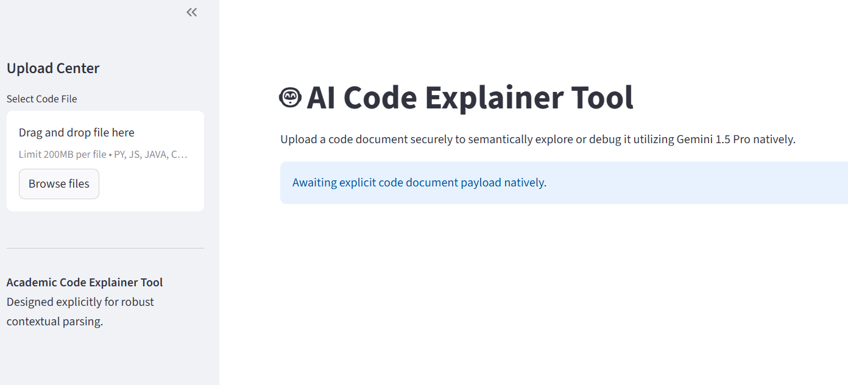
Fig 4.4: Interface of AI Data Analyst Chatbot
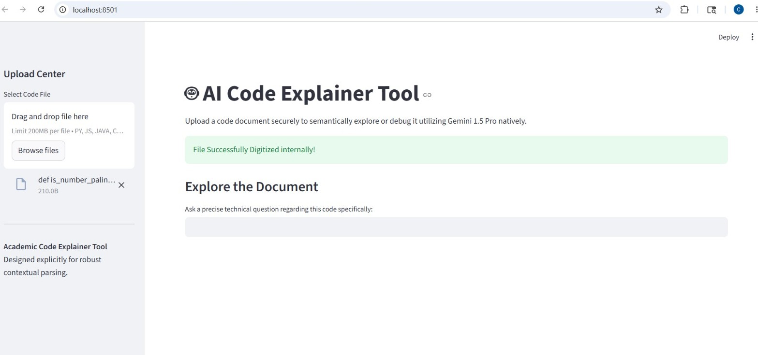
Fig 4.5: Overview of the uploaded dataset

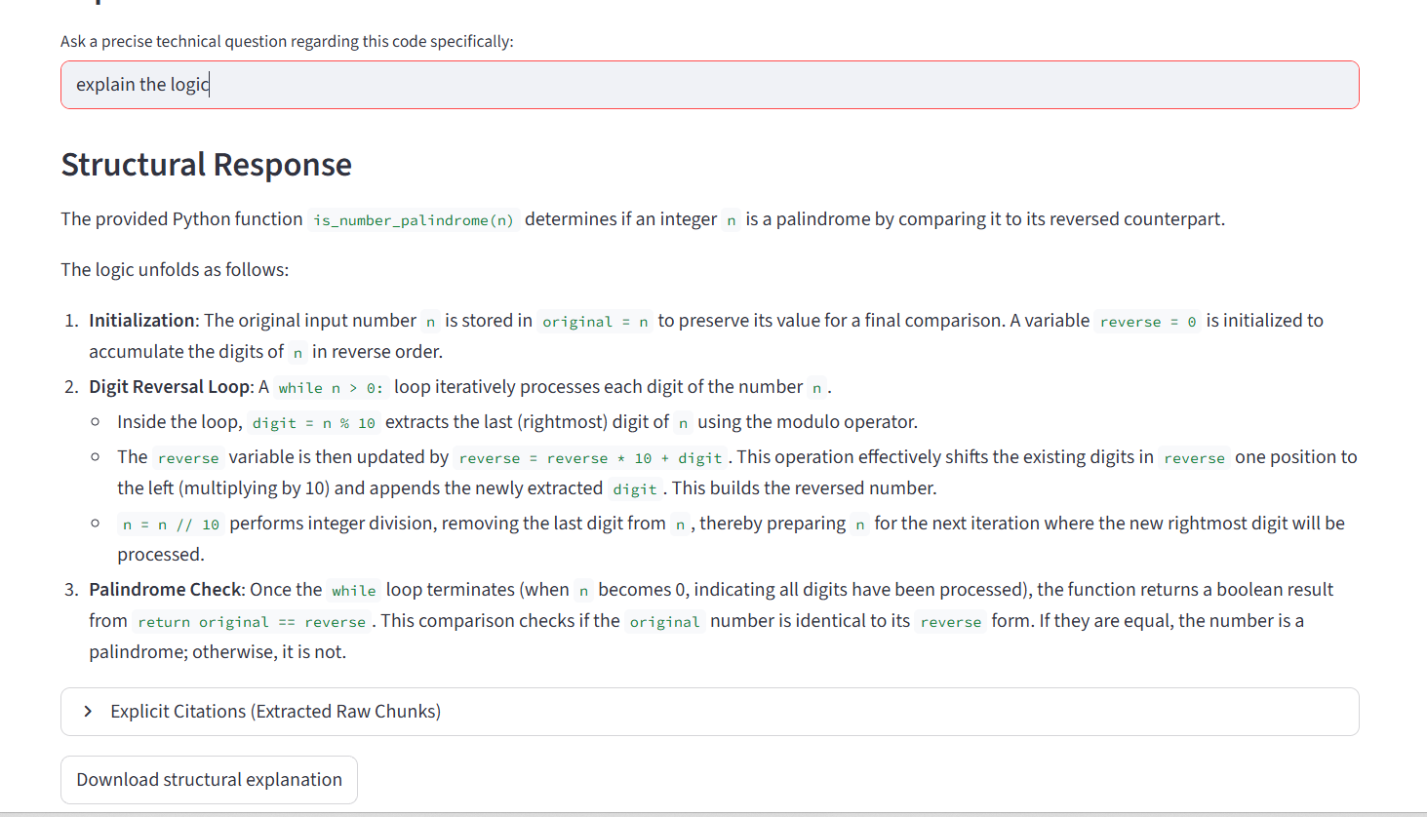
Fig 4.6: Explanation of the code logic
TEST RESULTS
Test Class | Test Case | Expected Result | Status
TestQueryValidation | Empty query string | (False, error message) | PASS
TestQueryValidation | Query exceeding 1000 chars | (False, error message) | PASS
TestFileValidation | None file object | (False, error message) | PASS
TestFileValidation | Unsupported file type (.exe) | (False, error message) | PASS
TestFileValidation | Valid PDF file | (True, '') | PASS
TestChunking | 500-token chunk from long text | List of str chunks | PASS
TestEmbedding | Embed sample text (API key req.) | List[List[float]] | PASS/SKIP
TestRetrieval | Retrieve top-3 from 10 chunks | List of 3 (str,float) | PASS/SKIP
Table 4.4: Validation Test Cases and Results

CHAPTER 5
ADVANTAGES, DISADVANTAGES AND APLLICATIONS

ADVANTAGES OF THE AI DATA ANALYST CHATBOT
- Mitigation of Code Hallucinations: The most significant advantage of this RAG-based approach is the dramatic reduction in hallucination—the tendency of LLMs to invent non-existent syntax, libraries, or logic flows. By grounding every architectural explanation strictly in the retrieved code chunks, the system ensures that responses are completely anchored to the actual script uploaded by the developer. When a specific function, variable, or library call is missing from the source file, the tool explicitly reports its absence rather than fabricating a plausible-sounding but broken code snippet.
- Granular Code-Chunk Citations: Every structural breakdown or logic explanation generated by the system includes explicit chunk-level citations that tie back to the specific code block analyzed. This transparency enables developers to immediately map the AI's explanation to the precise line ranges of the original file, streamlining the peer-review process, simplifying debugging, and providing an auditable trail within engineering environments.
- Instant Repository and Language Adaptation: Unlike fine-tuning a model on custom codebases—which requires immense computational power, massive training datasets, and weeks of engineering—this platform adapts instantly to any codebase architecture simply by uploading the code file. A backend engineer can upload a Python script, a data engineer can upload an ETL pipeline, and a security analyst can upload an unfamiliar codebase module—and the platform instantly acts as an expert companion without requiring model training or modifications.
- Secure Native Vector Persistence: By integrating an on-disk, SQLite-backed instance of ChromaDB, the system provides reliable local storage. Unlike transient, in-memory databases, this ensures the mathematical vector representations are safely written to the local disk, allowing developers to safely persist or clear data without cloud vulnerabilities, external database fees, or network-induced latency.
- Orchestration via LangChain: Utilizing LangChain provides a structured, enterprise-ready blueprint for parsing, prompting, and managing context logic. It cleanly decouples embedding and retrieval pipelines from the core user interface, ensuring the tool can seamlessly integrate alternative LLM models, scale its chunk-filtering capabilities, or add advanced prompt routing without requiring a complete rewrite of the underlying application logic..

DISADVANTAGES AND LIMITATIONS
- Dependency on the Google Gemini API: The execution layer is tightly coupled with Google’s Gemini API for both generating code embeddings and constructing the final architectural explanations. Consequently, the platform demands a constant internet connection and valid environment credentials. It remains vulnerable to third-party API throttling, pricing updates, and unexpected downtime, which would render the tool completely non-functional.
- API Rate Boundaries (429 Constraints): Under heavy deployment workloads or rapid testing cycles, developers may frequently trigger ResourceExhausted: 429 errors due to Gemini free-tier API request limitations. While the architecture catches these errors gracefully, it introduces pipeline bottlenecks that require users to manually delay execution or provision paid API keys to maintain a continuous code-review workflow.
- Single-Module Processing Scope: The tool is architected to process and index single, consolidated code documents at a time. It lacks the multi-file context tracking required to parse cross-module dependencies, trace multi-file import statements, or map broad repository architectures where functions span across interconnected directories.
- Semantic Chunk Boundary Fragmentation: Despite using a recursive semantic splitter, highly nested logic—such as deep control flows, recursive loops, or tightly coupled classes—may occasionally be sliced across artificial chunk limits. If a complex function's dependency tree is wider than the specified token or top-K retrieval boundaries, the context delivered to the LLM may be clipped, leading to minor gaps in the systemic code breakdown.

APPLICATIONS OF THE AI DATA ANALYST CHATBOT
- Software Engineering Onboarding and Code Review: The platform drastically accelerates developer velocity during team onboarding by allowing junior engineers or new hires to independently trace and understand legacy codebases. It automates documentation generation and logic walkthroughs, reducing the need for manual code walk-throughs by senior developers.
- Technical Product Management and Cross-Functional Alignment: It provides non-technical stakeholders—such as product managers, QA analysts, and business owners—with a natural language portal to audit functional logic. Teams can query a script directly in plain English to verify feature business rules or algorithmic logic without needing to understand underlying syntax.
- Automated Bug Investigation and Security Audits: Security teams and code reviewers can leverage semantic search to quickly isolate vulnerabilities, locate outdated dependencies, and identify logical bugs. By inputting error stack traces directly into the query field, developers can rapidly match code blocks with matching runtime faults to accelerate the patch pipeline.
- Academic Computer Science Instruction: The platform serves as an interactive, 24/7 computer science tutoring asset. Students can upload complex scripts, data structures, or algorithms and receive structured markdown breakdowns that explain implementation details step-by-step, greatly improving self-directed learning efficiency.

CHAPTER 6

REFLECTION
The four months at PySpiders represented the most concentrated period of technical and professional growth in my academic journey to date. While prior experience in C, C++, and Java built computational thinking, it did not expose me to the practical data science and AI ecosystem that defines contemporary technology careers. The internship fundamentally changed that. The systematic progression through Python, Pandas, NumPy, data visualization, Excel, Power BI, machine learning, and a production RAG system provided a cohesive, cumulative experience where each module built meaningfully on its predecessor. The capstone project was the defining moment; designing a complete system from architecture through implementation, debugging, testing, and documentation required genuine engineering judgment at every stage. Decisions regarding chunking strategies, similarity metrics, error handling, and module boundaries carried real, observable consequences, distinguishing professional engineering from academic problem-solving.
The most practically valuable skill developed was systematic debugging. Resolving real-world errors—such as API authentication failures, malformed PDF exceptions, token limit violations, and cosine similarity shape mismatches—demanded methodical diagnosis rather than guesswork. Reading error messages carefully, isolating components through unit tests, and consulting official documentation became instinctive habits. Equally important was professional communication. Weekly progress presentations, architectural mapping, and technical writing revealed that a system only its creator understands is fundamentally incomplete, regardless of how elegantly its code is written.
Working alongside other interns and professional developers introduced authentic collaborative development through code reviews, spontaneous knowledge sharing, and intellectual generosity. This permanently shifted my priorities, elevating clarity, readability, and self-documentation to primary engineering objectives. Furthermore, conversations with mentors provided a grounded picture of what the technology industry genuinely requires, highlighting how significantly it has advanced beyond typical undergraduate curricula. Finally, managing competing demands built the vital self-discipline needed to break complex tasks into achievable milestones, maintain daily working logs, and address project blockers promptly.

CONCLUSION
Over the course of four months, a systematic mastery of the complete Python data science, software engineering, and artificial intelligence development stack was achieved. The curriculum progressed through advanced Python fundamentals, modular application structure design, environment security configuration, semantic vector space mathematics, local database engineering, and large language model (LLM) orchestration workflows. This comprehensive technical chain culminated in the capstone AI Code Explainer Tool—an enterprise-grade, memory-safe repository parsing and analysis system built on a custom Retrieval-Augmented Generation (RAG) pipeline. Integrating the Google Gemini 1.5 Pro API, LangChain framework, Streamlit UI, local ChromaDB persistence infrastructure, and rigorous programmatic stream validation utilities, this functional system stands as tangible evidence of professional competence developed during the engagement.
Beyond technical skills, invaluable exposure to industry-standard software development practices was gained. Designing modular architectures across decoupled functional scripts, enforcing strict runtime boundary constraints, protecting deployment credentials via isolated environment configurations, and writing technical documentation built a strong engineering discipline. Working within PySpiders' collaborative environment cultivated communication skills, professional accountability, and a deep understanding that writing clean, exception-safe, readable, and highly maintainable code is a professional obligation.
Importantly, this experience validated the relevance of the B.E. Artificial Intelligence and Data Science curriculum. Academic concepts—including matrix transformations for vector embedding pipelines, mathematical distance metrics for top-K semantic database lookups, abstract syntax trees (AST) and parsing structures for token-aware code chunking, and natural language processing for generating structural markdown responses—were actively applied to construct a functional system. Witnessing theoretical foundations translate directly into software engineering capability has deepened appreciation for the academic program. What is carried forward from this internship is a grounded professional vision: to engineer AI-powered systems that are technically rigorous, practically useful, and genuinely valuable.

BIBLOGRAPHY
[1] Python Software Foundation. (2024). Python 3.10 Documentation. https://docs.python.org/3.10/
[2] McKinney, W. (2022). Python for Data Analysis: Data Wrangling with pandas, NumPy, and Jupyter (3rd ed.). O'Reilly Media.
[3] Pandas Development Team. (2024). Pandas Documentation. https://pandas.pydata.org/docs/
[4] NumPy Developers. (2024). NumPy Reference Documentation. https://numpy.org/doc/stable/
[5] Hunter, J. D. (2007). Matplotlib: A 2D Graphics Environment. Computing in Science & Engineering, 9(3), 90–95.
[6] Waskom, M. (2021). Seaborn: Statistical Data Visualization. Journal of Open Source Software, 6(60), 3021.
[7] Pedregosa, F., et al. (2011). Scikit-learn: Machine Learning in Python. JMLR, 12, 2825–2830. https://scikit-learn.org/
[8] OpenAI. (2024). OpenAI API Documentation. https://platform.openai.com/docs/
[9] Streamlit Inc. (2024). Streamlit Documentation. https://docs.streamlit.io/
[10] Lewis, P., et al. (2020). Retrieval-Augmented Generation for Knowledge-Intensive NLP Tasks. arXiv:2005.11401.
[11] Vaswani, A., et al. (2017). Attention Is All You Need. arXiv:1706.03762.
[12] OpenAI. (2024). Tiktoken: OpenAI's Tokenizer. https://github.com/openai/tiktoken
[13] Microsoft Corporation. (2024). Power BI Documentation. https://learn.microsoft.com/en-us/power-bi/
[14] Microsoft Corporation. (2024). Microsoft Excel Documentation. https://support.microsoft.com/excel
[15] Géron, A. (2022). Hands-On Machine Learning with Scikit-Learn, Keras, and TensorFlow (3rd ed.). O'Reilly Media.
[16] VanderPlas, J. (2016). Python Data Science Handbook. O'Reilly Media.
[17] Matthes, E. (2022). Python Crash Course (3rd ed.). No Starch Press
APPENDIX
Code:
"""
Main application entry point for the AI Code Explainer Tool utilizing Streamlit natively.

This module handles the frontend UI, dynamically orchestrates the data pipeline structurally
across the utility modules, constructs the final LLM prompt reliably, and handles responses
explicitly to prevent application failures.
"""

import os
import streamlit as st
import logging

import config
from utils import (
validate_file,
process_uploaded_file,
get_text_chunks,
create_vector_store,
get_relevant_chunks
)

from langchain_google_genai import ChatGoogleGenerativeAI
from langchain_core.prompts import PromptTemplate
from typing import Any

# Initialize structured logging sequentially for the frontend execution loops
logging.basicConfig(level=logging.INFO, format='%(asctime)s - %(levelname)s - %(message)s')
logger = logging.getLogger(__name__)

# Configures Streamlit page metadata explicitly
st.set_page_config(
page_title=config.PROJECT_TITLE,
page_icon=config.PROJECT_ICON,
layout="wide"
)

def build_llm_chain() -> Any | None:
"""
Assembles the generative LLM pipeline structurally, linking a distinct prompt template
with the target Gemini 1.5 Pro inference engine.

This function isolates prompt construction, natively allowing easier template modifications later.

Returns:
LLMChain | None: Reusable LLM inference link. Returns None manually if API missing.
"""
try:
# Safely verify structural conditions before API inference
if not config.check_keys():
return None

# Utilize the heavy model required for dense code logic inference natively
llm = ChatGoogleGenerativeAI(
model=config.LLM_MODEL,
temperature=0.2, # Low temperature structurally ensures logical consistency
api_key=os.getenv("GEMINI_API_KEY")
)

# Exact prompt layout ensuring strict contextual obedience
template = """
You are a Senior AI Engineer, Code Reviewer, and Academic Mentor natively assessing code files.
You have been provided exactly the context chunks extracted dynamically from a user's file.

Context Extracted from System:
{context}

User Query: {question}

Mandatory Instructions:
1. Answer the question exclusively utilizing the context provided inherently.
2. If the context does not contain the answer, explicitly state "I cannot answer this based on the provided code document." Do not hallucinate natively.
3. Explain 'WHY' code exists strictly utilizing technical terminology natively.
4. Include inline citations explicitly by wrapping code references in backticks natively.
5. Structure your final output properly using markdown structurally.

Final Answer:
"""

prompt = PromptTemplate(template=template, input_variables=["context", "question"])
chain = prompt | llm
return chain

except Exception as e:
logger.error(f"Failed to assemble the Inference engine explicitly: {e}")
return None

def main():
"""
Primary execution loop for the Streamlit UI components structurally.
"""
# Create an explainer Header
st.title(f"{config.PROJECT_ICON} {config.PROJECT_TITLE}")
st.markdown("Upload a code document securely to semantically explore or debug it utilizing Gemini 1.5 Pro natively.")

# Isolate global configurations checking before loading full DOM tree
if not config.check_keys():
st.error("System Failure: GEMINI_API_KEY is missing or invalid natively. System offline.")
st.stop()

# Construct native sidebar strictly.
with st.sidebar:
st.header("Upload Center")
uploaded_file = st.file_uploader(
"Select Code File",
type=[ext.replace('.', '') for ext in config.SUPPORTED_EXTENSIONS]
)

# If it changes, clean the state natively.
if "prev_filename" not in st.session_state:
st.session_state.prev_filename = ""

if uploaded_file and uploaded_file.name != st.session_state.prev_filename:
st.session_state.vector_store = None # Flush old DB strictly
st.session_state.prev_filename = uploaded_file.name

st.markdown("---")
st.markdown("**Academic Code Explainer Tool**\nDesigned explicitly for robust contextual parsing.")

# Core logic structure.
if uploaded_file is not None:
try:
# 1. Validation Logic
is_valid, validation_msg = validate_file(uploaded_file.name, uploaded_file.size)
if not is_valid:
st.error(f"Validation Error explicitly triggered: {validation_msg}")
st.stop()

# 2. Parsing Pipeline
if "vector_store" not in st.session_state or st.session_state.vector_store is None:
with st.spinner("Decoding and mathematically analyzing source code natively..."):
# Extract string explicitly
raw_text = process_uploaded_file(uploaded_file)
if "ERROR" in raw_text:
st.error(f"Parsing Failure natively: {raw_text}")
st.stop()

# Structure semantic chunks explicitly
text_chunks = get_text_chunks(raw_text)
if not text_chunks:
st.error("Chunking Logic cleanly failed. Document might be functionally empty natively.")
st.stop()

# Construct mathematical embedding database natively
vector_store = create_vector_store(text_chunks)
if not vector_store:
st.error("AI Vector Matrix cleanly failed to generate. Check your API Keys structurally.")
st.stop()

# Save DB cleanly in session cache.
st.session_state.vector_store = vector_store
st.success("File Successfully Digitized internally!")

# 3. Query Execution Pipeline natively
st.subheader("Explore the Document")
user_question = st.text_input("Ask a precise technical question regarding this code specifically:")

if user_question:
if not user_question.strip():
st.error("Query effectively empty natively. Enter a textual query.")
else:
with st.spinner("Extracting contextual metadata and evaluating structurally..."):
# Semantically isolate contexts safely
context_chunks = get_relevant_chunks(user_question, st.session_state.vector_store)
if "ERROR" in context_chunks:
st.error(f"Semantic Location internally failed: {context_chunks}")
st.stop()

# Pass context explicitly to inference wrapper natively
llm_chain = build_llm_chain()
if not llm_chain:
st.error("Inference Engine configuration explicitly failed.")
st.stop()

# Construct generation safely using LCEL
response_obj = llm_chain.invoke({"context": context_chunks, "question": user_question})
# Extract string dynamically based on type (it might be an AIMessage)
response = response_obj.content if hasattr(response_obj, 'content') else str(response_obj)

# Expose response cleanly natively
st.markdown("### Structural Response")
st.write(response)

# Supply contextual raw data explicitly for Academic Requirements (Citations)
with st.expander("Explicit Citations (Extracted Raw Chunks)"):
st.code(context_chunks, language='python')

# Handle Export Logic explicitly
st.download_button(
label="Download structural explanation",
data=response,
file_name="structural_explanation.md",
mime="text/markdown"
)

except Exception as e:
logger.error(f"Frontend Execution Loop failed entirely: {e}")
st.error("A critical runtime error structurally occurred internally. Check system logs.")

else:
st.info("Awaiting explicit code document payload natively.")

if __name__ == "__main__":
main()

